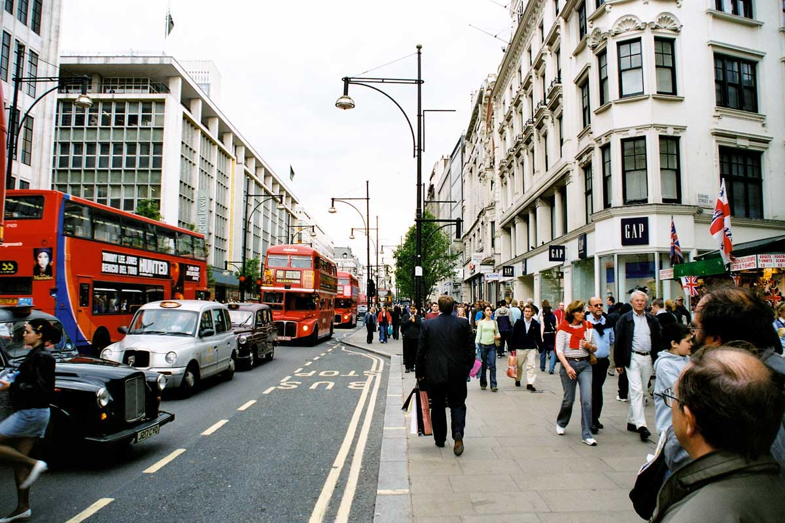
Oxford Street

I think Oxford Street is one of the most beautiful streets in London. There are many shops from very cheap up to very expensive. You can find everything there what you want. You can buy clothes up to shoes and computer games; everything is possible in that street.
My impressions were great. You came in the street and there were so many people in the street, and there were many buses in the street. I love it to see the many stores and the beautiful big department stores. But when there are so many people it’s very small for everybody I think there are more than 10000 people in the street every day.
But the people are very friendly you can see there so many people from every country, the streets and London are very multicultural.
Rusty Joecks, 10 c

