Oxford
On Wednesday we were in Oxford. Oxford is a beautiful city. There are lots of old colleges. Did you know that? Many of Harry Potter movies were taken there. Some Colleges are 750 years old. When you want to go at a college there, you need an average of 1,0 in your Abitur. But then you must pass an exam at the college, before you can start. The colleges are very expensive. Just rich people can go on these colleges.
Oxford has a little pedestrian precinct and has an old history.
We went from London to Oxford one and a half hours. We had a guide through the city. We were at Balliol College, which belongs to the oldest colleges in England.
We all liked Oxford very much!

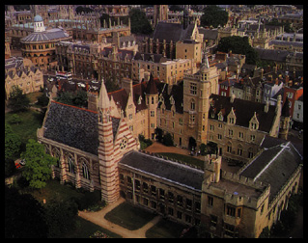 Mara Genske & Fenja Toll, 10c

